**CENWP-ODVR02 August 2023**

**MEMORANDUM FOR THE RECORD**

**SUBJECT: 23CMR01 Concrete inspections**

As of 01 August, NWP Dive Ops complete the Cole M. Rivers dive and ROV operations.

Divers removed a tote full of rocks, balls of fishing line, garbage and other debris from the entrance pool and fish ladder. Inspections were completed of the ladder grating, valves, concrete and other structures with no discrepancies found. ROV inspection of the 6 adult holding ponds did not reveal any structural issues as well. We were able to utilize the ROV to determine that the inlet water valve # 1 had woody debris keeping the valve from fully closing. Manipulations of the valve and clearing with a pike pole allowed hatchery personnel to clear the valve and return it to normal operations.

02 August, Dive Ops will pick up the trailer from Lost Creek travel back. They will process the dive operation videos and send to ODT-F later this week.

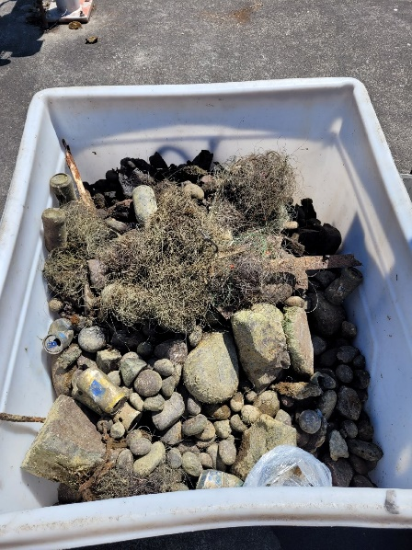 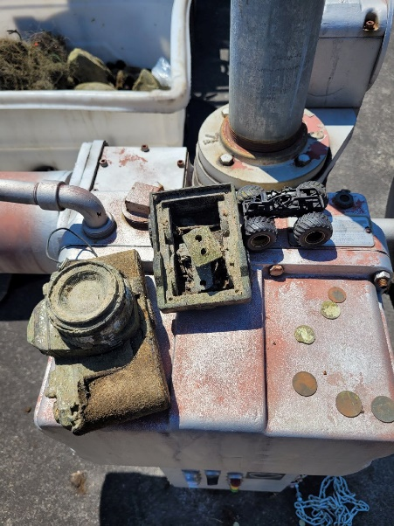 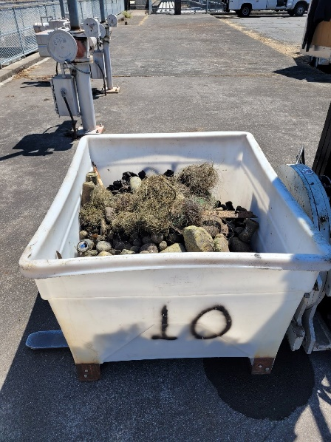

Items collected from the entrance pool and fish ladder.

Sincerely,

ODT-F